Pf theory assignment 1
QUESTION 1:
PAC CHART:
GIVEN DATA | REQUIRED RESULT | PROCESSING | SOLUTION ALTERNATIVES
Amount spent | Decide if suspicious. | Add transaction value to amount spent to get new total | Output immediate flags based on a chosen threshold.
Transaction value | Output reasons of suspicion. | Check if new total is greater than transaction limit. | Check suspiciousness by score based system.
Transaction limit |  | Check if transaction country is equal or not to either usual country.
Transaction country |  | Check if no of transactions per hour > 3.
Number of transactions per hour |  | Print flags based on answers.
Usual Transaction country 1 |  | Print reasons of suspicions.
Usual Transaction country 2

IPO CHART:

INPUTS | PROCESS | OUTPUTS
Amount spent | Compute new total | Required message for each suspicion:
Transaction value | Check given conditions | - TRANSACTION LIMIT EXCEEDED  - FOREIGN COUNTRY  - TOO MANY TRANSACTIONS PER HOUR
Transaction limit | Display the necessary outputs. | Output “Transaction is normal” if no flags alerted.
Transaction country
Number of transactions per hour
Usual Transaction country 1
Usual Transaction country 2

ALGORITHM:
READ Amount spent
READ Transaction value
READ Transaction country
READ Number of transactions per hour
READ Usual Transaction country 1 and Usual Transaction country 2
READ Transaction limit
COMPUTE new total = Transaction value + Amount spent
IF new total > transaction limit then print flag for daily limit
IF Transaction country not equal to Usual Transaction country 1 OR Usual Transaction country 2 print flag for foreign country.
IF Number of transactions per hour > 3 then print flag for too many transactions.
IF no flags printed, print “Transaction seems normal”

PSEUDOCODE:
START
INPUT amount_spent
INPUT transaction_value
INPUT transaction_country
INPUT transactions_per_hour
INPUT usual_country_1
INPUT usual_country_2
INPUT transaction_limit

SET new_total = amount_spent + transaction_value
SET suspicious = false

IF new_total > transaction_limit THEN
PRINT "Flag: DAILY LIMIT EXCEEDED"
SET suspicious = true
ENDIF

IF transaction_country ≠ usual_country_1 AND transaction_country ≠ usual_country_2 THEN
PRINT "Flag: FOREIGN COUNTRY"
SET suspicious = true
ENDIF

IF transactions_per_hour > 3 THEN
PRINT "Flag: TOO MANY TRANSACTIONS IN AN HOUR"
SET suspicious = true
ENDIF

IF suspicious = false THEN
PRINT "Transaction seems normal."
ENDIF
END

FLOWCHART:
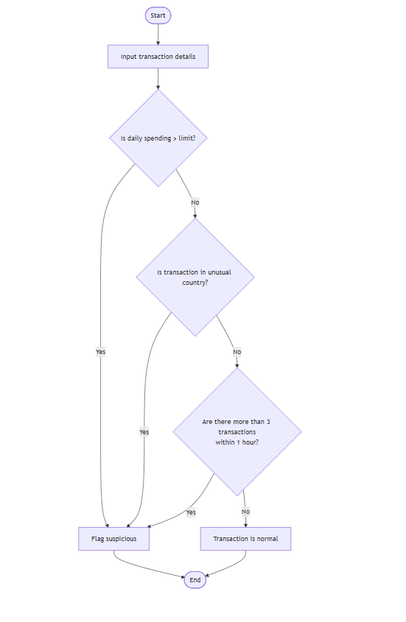

C language

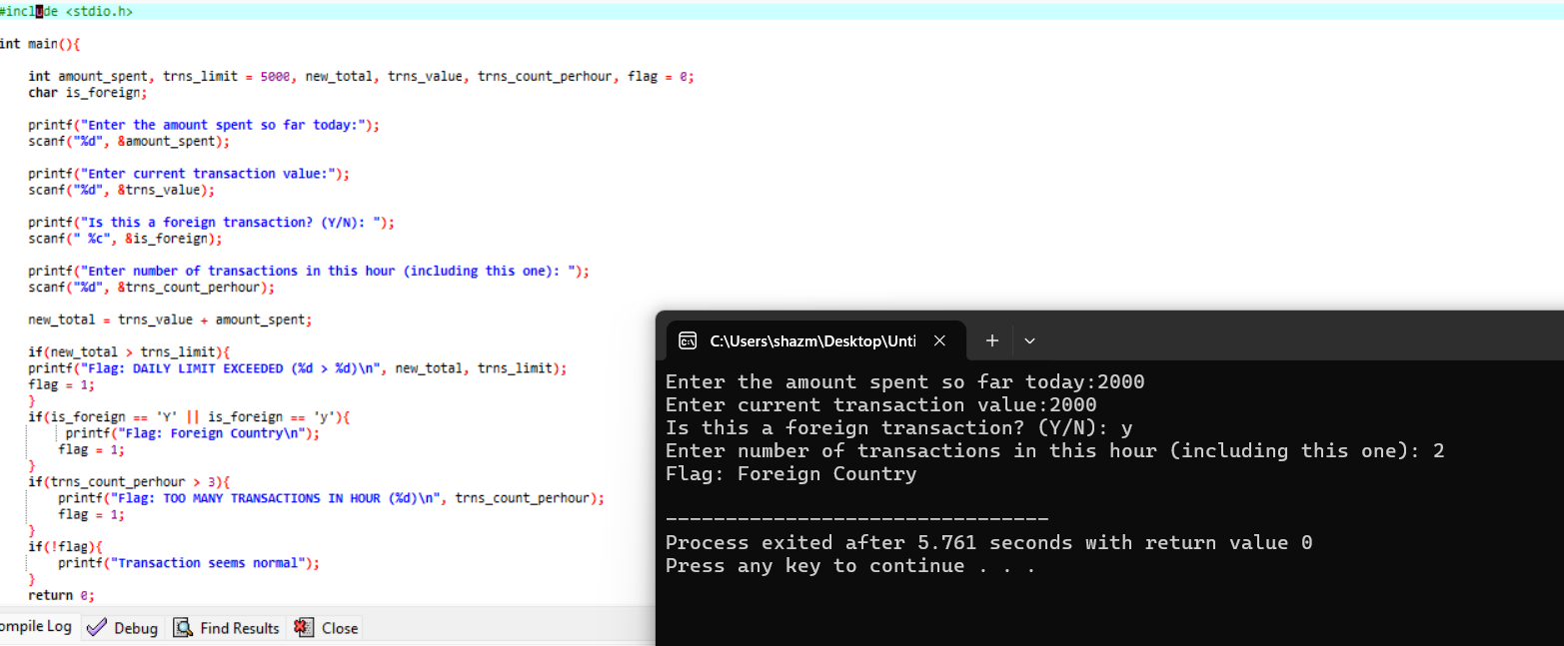

Question 2:

PAC CHART:
GIVEN DATA | REQUIRED RESULT | PROCESSING | ALTERNATIVE SOLUTIONS
Coordinates of a point | Identify quadrant in which point lies | If x>0 and y>0  Point lies in Quadrant I | Use a reference graph to compare the points to quadrants.
x-coordinate |  | If x<0 and y>0  Point lies in Quadrant II
y- coordinate |  | If x<0 and y<0  Point lies in Quadrant III
If x>0 and y<0
Point lies in Quadrant IV
If x==0 and y==0
Point lies on origin

IPO CHART:

INPUTS | PROCESS | OUTPUTS
x coord | Check signs of x and y | Print quadrant or axis.
y coord

ALGORITHM:
READ x_coord
READ y_coord
IF x > 0 and y > 0 then print Quadrant I
ELSE if x < 0 and y > 0 then print Quadrant II
ELSE if x < 0 and y < 0 then print Quadrant III
ELSE if x > 0 and y < 0 then print Quadrant IV
ELSE print "Point lies on axis"

PSEUDOCODE:
START
INPUT x_coord
INPUT y_coord

IF x_coord > 0 AND y_coord > 0 THEN
PRINT "Point lies in Quadrant I"
ELSE IF x_coord < 0 AND y_coord > 0 THEN
PRINT "Point lies in Quadrant II"
ELSE IF x_coord < 0 AND y_coord < 0 THEN
PRINT "Point lies in Quadrant III"
ELSE IF x_coord > 0 AND y_coord < 0 THEN
PRINT "Point lies in Quadrant IV"
ELSE IF x_coord = 0 AND y_coord = 0 THEN
PRINT "Point lies at the Origin"
ELSE IF x_coord = 0 THEN
PRINT "Point lies on the Y-axis"
ELSE
PRINT "Point lies on the X-axis"
ENDIF

END
C CODE:
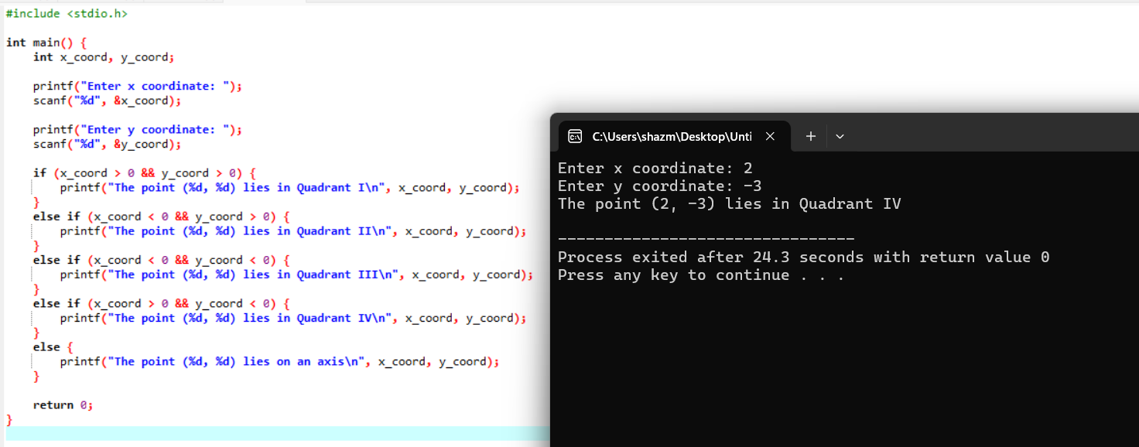

FLOWCHART:

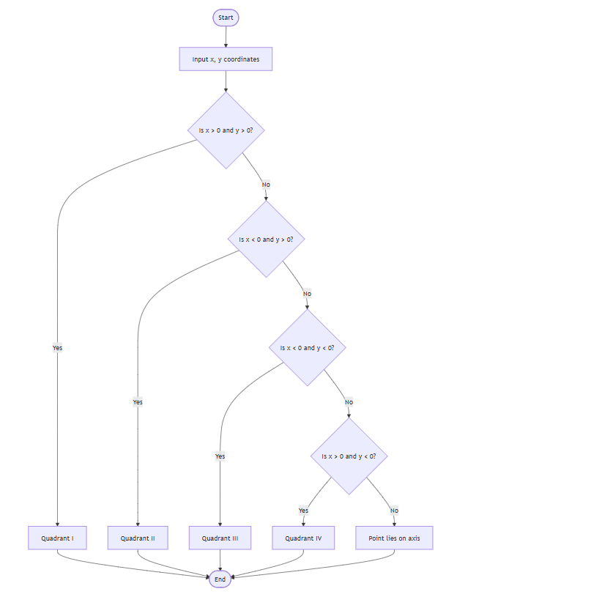

QUESTION 3:

PAC CHART:

GIVEN DATA | REQUIRED RESULT | PROCESSING | ALTERNATIVE SOLUTIONS
age | Decide if applicant is eligible for driving test or not | Check age of applicant | Flag based approach
eyesight result |  | Must pass eyesight test | Decision table.
written result |  | Must pass written result
driving result |  | Must pass driving test
medical result |  | Must have medical certificate for 60+ age.

IPO CHART:

INPUTS | PROCESS | OUTPUTS
age | Step by step decision making. | Output for eligibility or no eligibility for driving license-.
eyesight result
written result
driving result
medical result

ALGORITHM:
Read age
If age < 18 then print "Not eligible" then stop
Else ask eyesight result
If F then print "Not eligible, need glasses" then stop
Ask written result
If F then print "Not eligible, retake written test" then stop
Ask driving result
If F then print "Not eligible, failed driving test" then stop
Else if P and age ≤ 60 then print "Eligible" then stop
Else if P and age > 60 then ask medical certificate
If Y then print "Eligible"
Else print "Not eligible"

PSEUDOCODE:
START
INPUT age
IF age < 18 THEN
PRINT "Not eligible due to age"
STOP
ENDIF

INPUT eyesight_result
IF eyesight_result = 'F' THEN
PRINT "Not eligible, need glasses"
STOP
ENDIF

INPUT written_result
IF written_result = 'F' THEN
PRINT "Not eligible, must retake written test"
STOP
ENDIF

INPUT driving_result
IF driving_result = 'F' THEN
PRINT "Not eligible, failed driving test"
STOP
ELSE
IF age <= 60 THEN
PRINT "Eligible"
ELSE
INPUT medical_certificate
IF medical_certificate = 'Y' THEN
PRINT "Eligible"
ELSE
PRINT "Not eligible, no medical certificate"
ENDIF
ENDIF
ENDIF
END
FLOWCHART:
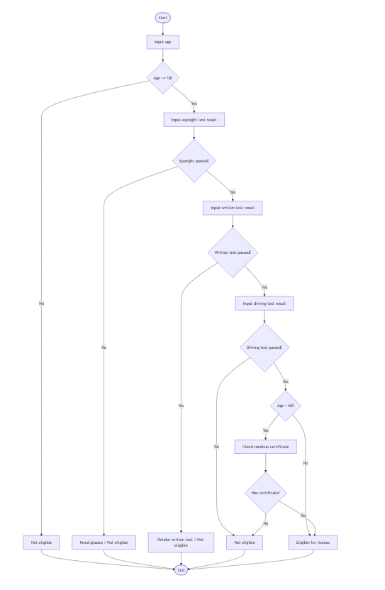
C CODE:
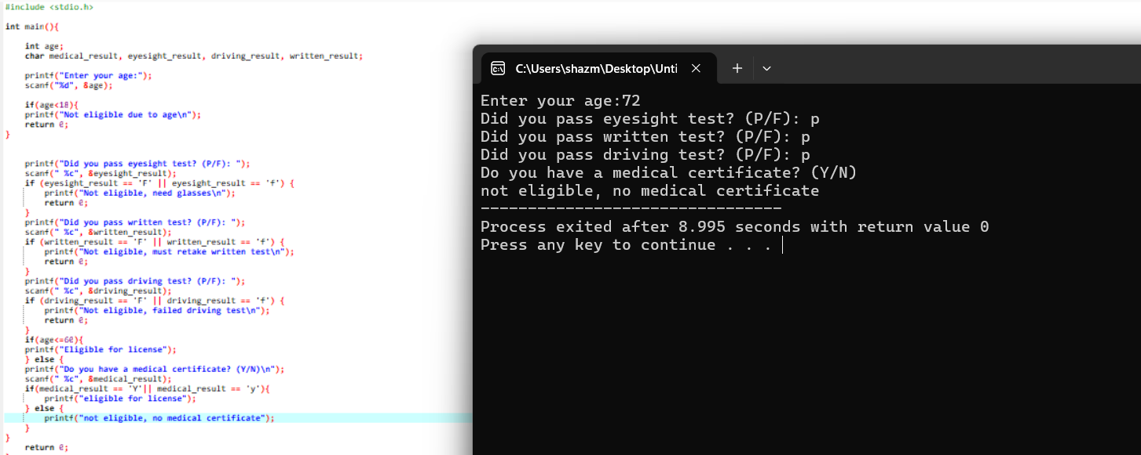

QUESTION 4:
PAC CHART:
GIVEN DATA | REQUIRED RESULT | PROCESSING | ALTERNATIVE SOLUTIONS
Poker hand | Check if hand is a full house | Compare each card with others. | Use loops to count frequency.
5 cards |  | Find out frequency of each card | Use arrays to count frequency.
1=ace |  | Determine if requirements of full house are met.
11=jack
12=queen
13=king

IPO CHART:
INPUTS | PROCESS | OUTPUTS
Five cards | Compare cards to count occurrences. | Display message if full house or not.
C1 | Check if any card occurs thrice and other occurs twice.
C2
C3
C4
C5

ALGORITHM:
Start.
Input 5 card values (c1, c2, c3, c4, c5).
Count how many times each card value occurs.
If one value occurs exactly 3 times and another value occurs exactly 2 times then print it is a Full House.
Otherwise print it is Not a Full House.
Display the result.
End.

PSEUDOCODE:
START
READ c1, c2, c3, c4, c5
SET counts for each card to 0
COMPARE cards and increase counts
IF (a card has count = 3) AND (a different card has count = 2) THEN
PRINT "Full House"
ELSE
PRINT "Not a Full House"
ENDIF
END
FLOWCHART:
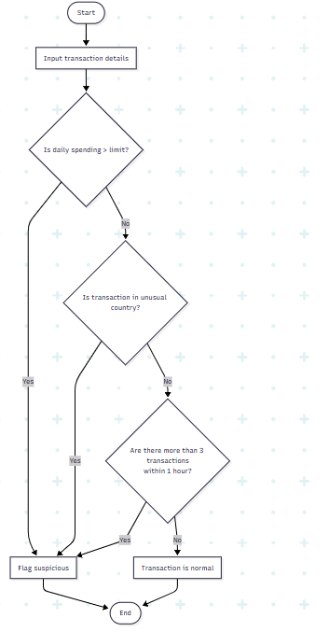
C CODE:
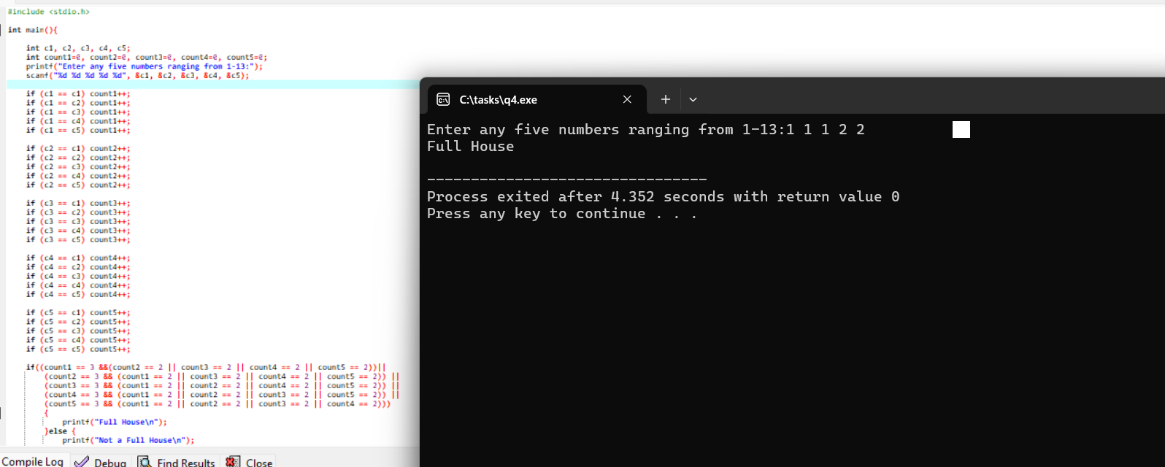

QUESTION 5:
PAC CHART:
GIVEN DATA | REQUIRED RESULT | PROCESSING | ALTERNATIVE SOLUTIONS
Numbers from 0-9 | Display how many times each number was entered | Read input numbers | Use arrays to store counts
Integers |  | If a number is between 0-9 increase its count | Use loops to store counts
 |  | If not don’t take input

IPO CHART:

INPUTS | PROCESS | OUTPUTS
Sequence of number(0-9) | Count how many times each number occurs. | Table which shows:
 |  | Each number and its number of occurrences.

ALGORITHM:

Start.
Initialize counters for digits 0–9 (all set to 0).
Read a number from the user.
If the number is between 0 and 9:
- Increase the corresponding counter.
- Ask for the next number.
If the input is not 0–9 then stop taking input.
Display the counters for all digits from 0 to 9.
End.

PSEUDOCODE:

START
SET count0 = 0
SET count1 = 0
SET count2 = 0
SET count3 = 0
SET count4 = 0
SET count5 = 0
SET count6 = 0
SET count7 = 0
SET count8 = 0
SET count9 = 0

REPEAT
INPUT number

IF number = 0 THEN
count0 = count0 + 1
ELSE IF number = 1 THEN
count1 = count1 + 1
ELSE IF number = 2 THEN
count2 = count2 + 1
ELSE IF number = 3 THEN
count3 = count3 + 1
ELSE IF number = 4 THEN
count4 = count4 + 1
ELSE IF number = 5 THEN
count5 = count5 + 1
ELSE IF number = 6 THEN
count6 = count6 + 1
ELSE IF number = 7 THEN
count7 = count7 + 1
ELSE IF number = 8 THEN
count8 = count8 + 1
ELSE IF number = 9 THEN
count9 = count9 + 1
ELSE
STOP input
ENDIF
UNTIL input stopped

PRINT "Number Number of Occurrences"
PRINT "0 ", count0
PRINT "1 ", count1
PRINT "2 ", count2
PRINT "3 ", count3
PRINT "4 ", count4
PRINT "5 ", count5
PRINT "6 ", count6
PRINT "7 ", count7
PRINT "8 ", count8
PRINT "9 ", count9
END
FLOWCHART:

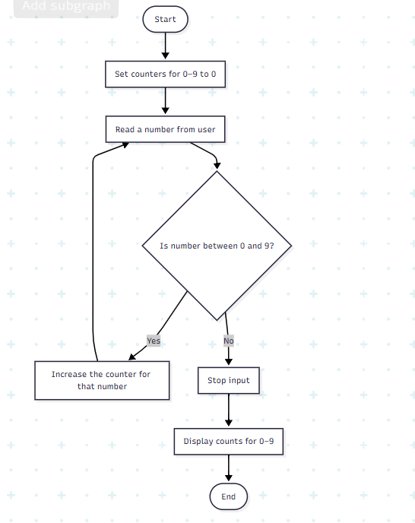

QUESTION 5 part b:

#include <stdio.h>

int counts[10] = {0};

void readNumber() {
int num;

printf("Enter a number (0-9), or any other number to stop: ");
if (scanf("%d", &num) != 1) {
return;
}

if (num < 0 || num > 9) {
return;
}

counts[num]++;

readNumber();
}

int main() {
readNumber();

printf("\nNumber Number of Occurrences\n");
printf("0 %d\n", counts[0]);
printf("1 %d\n", counts[1]);
printf("2 %d\n", counts[2]);
printf("3 %d\n", counts[3]);
printf("4 %d\n", counts[4]);
printf("5 %d\n", counts[5]);
printf("6 %d\n", counts[6]);
printf("7 %d\n", counts[7]);
printf("8 %d\n", counts[8]);
printf("9 %d\n", counts[9]);

return 0;
}

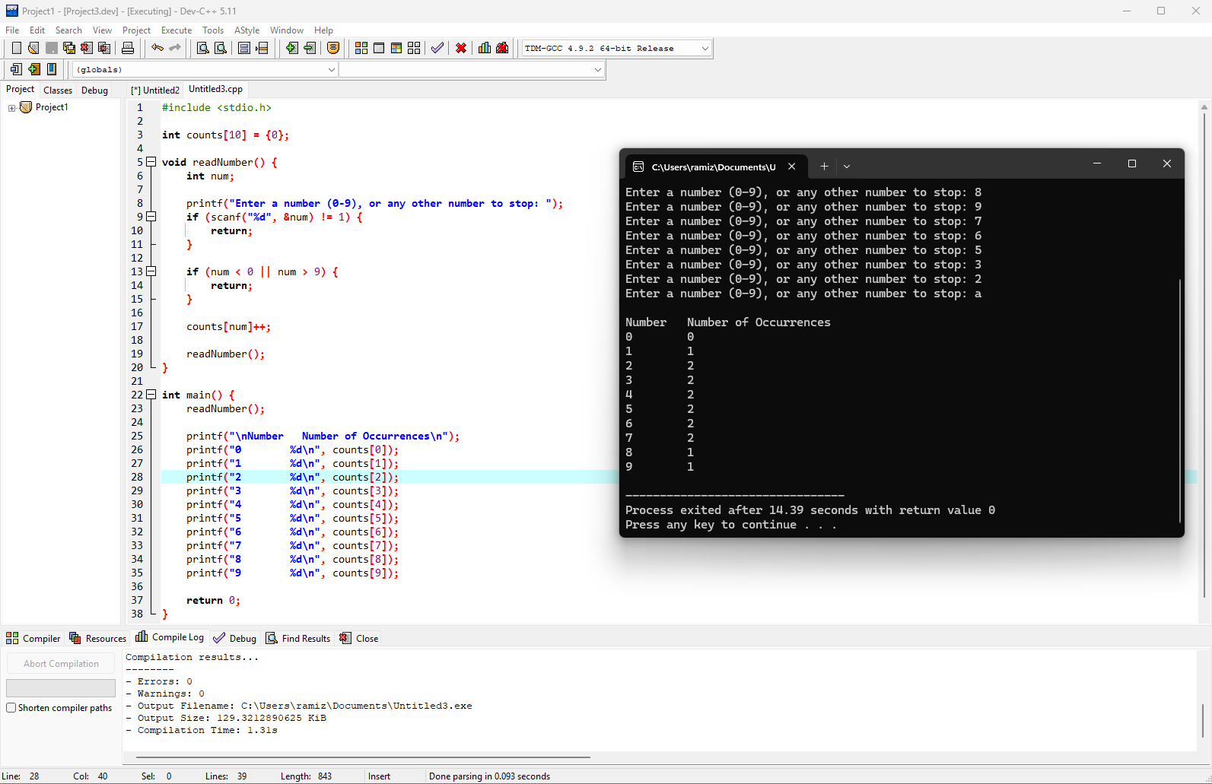

Question 6

Table of i, j, k and Output
i | j | k | Output
3 | 5 | 7 | 5, 5, 7
3 | 7 | 5 | 3, 5, 5
5 | 3 | 7 | 7, 3, 7
5 | 7 | 3 | 5, 3, 3
7 | 3 | 5 | 5, 3, 5
7 | 5 | 3 | 7, 3, 3

Question 7
#include <stdio.h>

int main() {
int value;

printf("Please enter a value in the range 1...7: ");
scanf("%d", &value);

switch (value) {
case 1:
printf("You entered Monday\n");
break;
case 2:
printf("You entered Tuesday\n");
break;
case 3:
printf("You entered Wednesday\n");
break;
case 4:
printf("You entered Thursday\n");
break;
case 5:
printf("You entered Friday\n");
break;
case 6:
printf("You entered Saturday\n");
break;
case 7:
printf("You entered Sunday\n");
break;
default:
printf("You entered a value out of range\n");
break;
}

return 0;
}

